**Using Other tools for observability**

* <https://github.com/asquarezone/ExpertKubernetes/commit/0aa4efb98c53fe911ce87e1ea3f52a9ef52cc3b5> for the sample application
* Now deploy the application 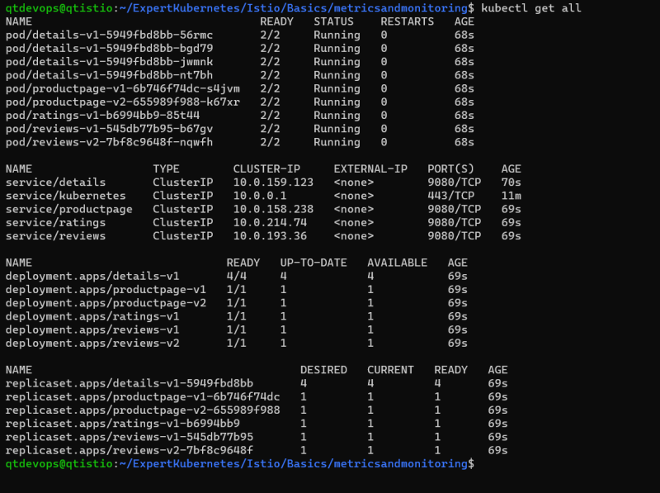
* Lets enable mtls <https://github.com/asquarezone/ExpertKubernetes/commit/e1e593f2ae485dfb6a0e8843f4f41a5475dc0d9f>
* Now lets try to run the application fortio generating load for 30 m

docker container run `

--add-host "bookinfo.com:20.84.9.83" `

fortio/fortio load -c 32 -qps 25 -t 30m http://bookinfo.com/productpage

docker container run `

--add-host "test.bookinfo.com:20.84.9.83" `

fortio/fortio load -c 32 -qps 25 -t 30m http://test.bookinfo.com/productpage

Tracing using Jaeger requires some change in the application, To do this Application needs to have the following HTTP Headers

* + x-request-id
  + x-b3-traceid
  + x-b3-spanid
  + x-b3-parentspanid
  + x-b3-sampled
  + x-b3-flags
  + x-ot-span-context

Please watch the recording of this session to trace, log and view metrics to make whole k8s with istio observable

Use the following configuration to setup EFK <https://github.com/asquarezone/ExpertKubernetes/tree/master/Istio/Basics/metricsandmonitoring/EFK> and also <https://logz.io/blog/logging-istio-with-elk-and-logz-io/>